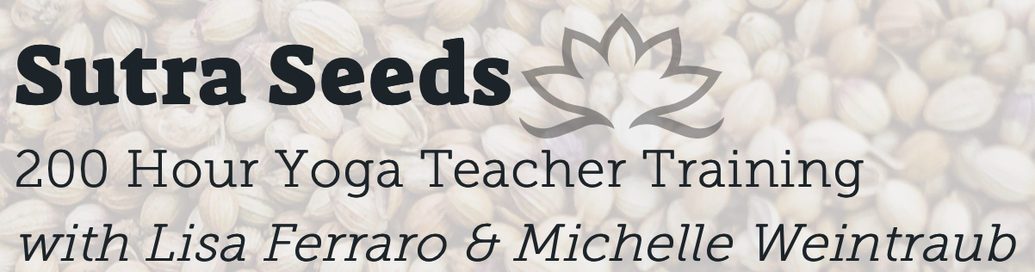

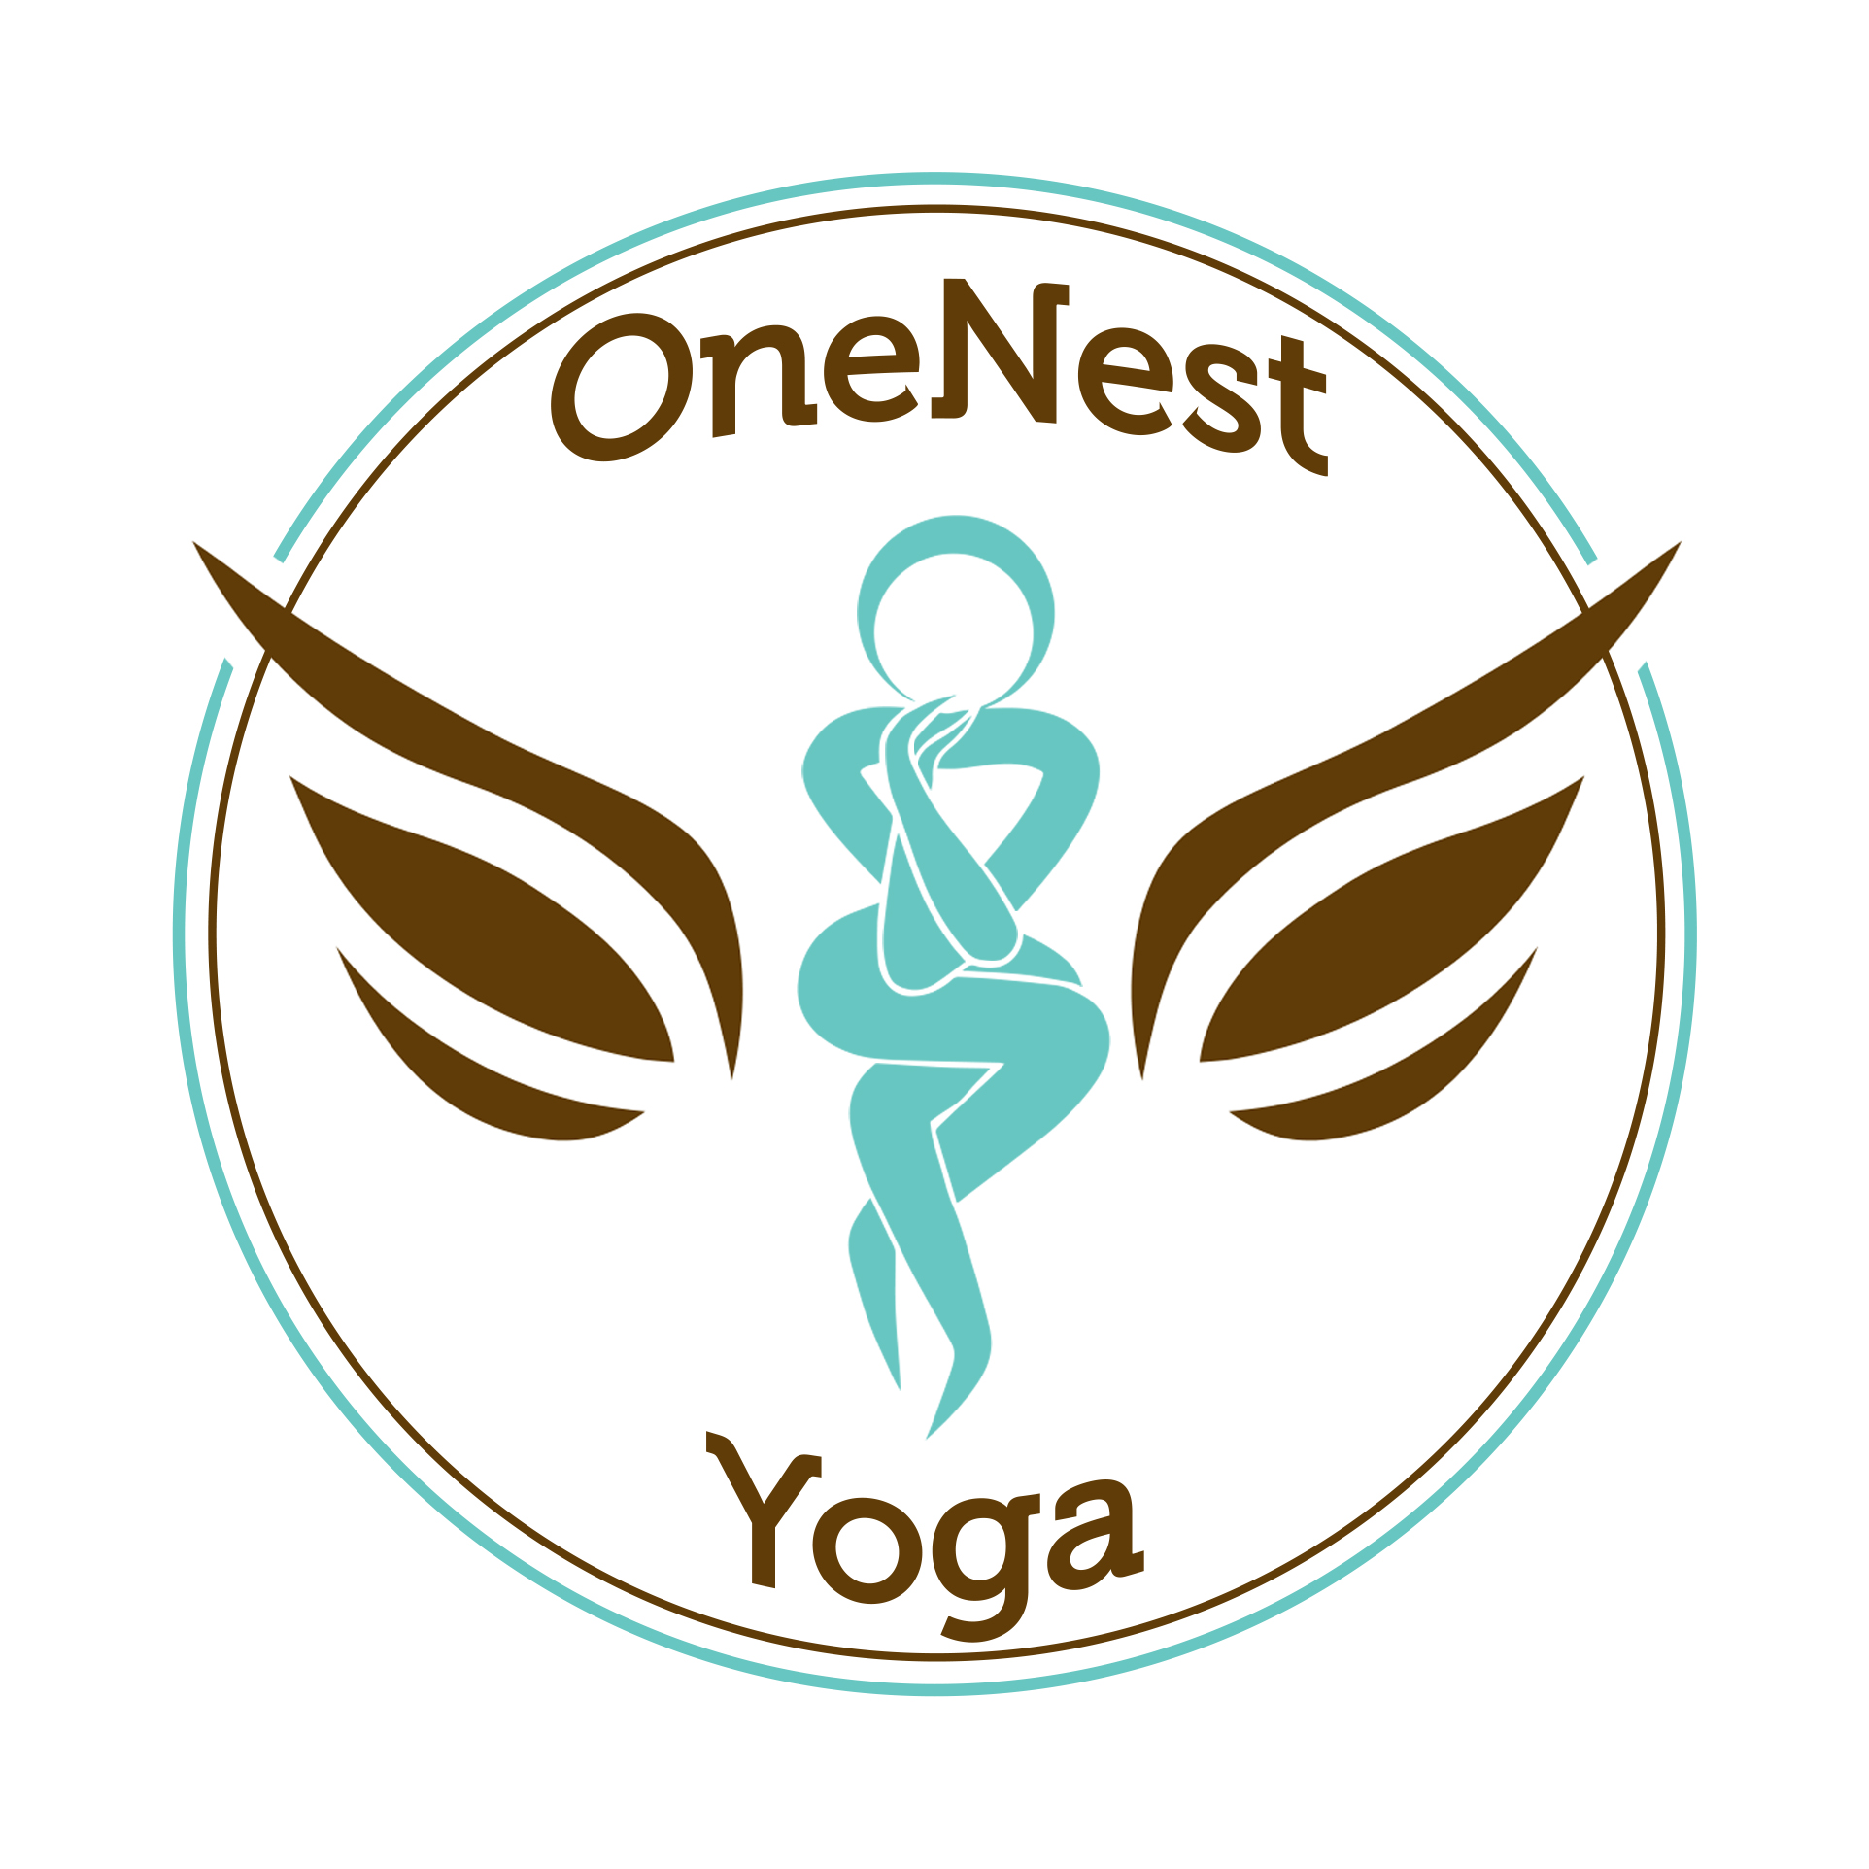
In partnership with OneNest Yoga Studio

APPLICATION

Share with us why you are here and feel great about this path you are entering from the first step to the “last”(there really is no “last” xo)

- What style of Yoga appeals/speaks to you?
- How long have you practiced Yoga?
- When was the first time you fell in love with Yoga?
- Why are you interested in Sutra Seeds 200 Hour Teacher Training?
- Which teachers do you currently practice with?
- Have you ever attended a Yoga workshop? If so, with who? When?
- What do you hope to gain from teacher training?
- What has Yoga taught you about yourself?
- Do you hope to teach or is this for your own personal practice?
- What scares you?
- Who supports you?
- What are your strengths? Your talents?
- What are your goals?
- Do you use mantras? Is there one you keep with you?
- Do you have a meditation practice?
- How does Yoga play a role in your life?
- Do you chant/sing/practice Kirtan?
- What is your name? Contact info (cell#/email/address)? Emergency Contact? Any allergies we should know about? Health History/surgeries/disabilities/special circumstances? Occupation?

We look forward to meeting you in person to learn more about each other.
Please let us know what day/night of the week we can schedule an
appointment to chat.

If you would like to email this application, please send to:
sutraseeds@gmail.com. The $25 application fee can be paid via Venmo (Michelle Weintraub) or Paypal (thesoapgirl@verizon.net). You can also pay through sutraseeds.com.
If you prefer to mail the application, please mail to:
Sutra Seeds
c/o Michelle Weintraub
832 East Broad Street
Westfield, NJ 07090

Checks are also accepted and can be made payable to:
Michelle Weintraub (please reference Sutra Seeds in the memo for your
records)
Questions? sutraseeds@gmail.com OR Michelle 201-401-3869/Lisa 917-653-9567

